Database Foundations:

* 1. : Introduction to Database

1.

ABC School District would like to create a student on-line information and registration system to capture student-related information. The system needs to be designed as an on-line process to

allow all new students to register on-line. It should also allow existing students to update and

review all information. Create a list of important data that would need to be captured and stored in the student registration database.

- Some important data that would need to be captured and stored would be the students personal information like their name, date of birth, address, student ID number, etc. Some other important data would be any parent/guardian information, emergency contacts, financial information, immunization records, medical records, academic records (grades, gpa, transcripts), enrollment information, login and password, and any legal documents needed for the school.

2.

XYZ community would like to create a library management system. The objective is for the

database to handle all transactions for the library. The database needs to store all the data that is relevant to managing the books, managing customers, and the day-to-day activities of the library. Create a list of important data that would need to be captured and stored in the library management database.

- Some important data for a library management system would be any book information (title, author, publisher, ISBN, etc.), customer information (library card, contact information, address, email, etc.), transaction history, book inventory, library staff and library contact information, and any events happening at the library.

* 1. : Database Models Practice
     1. Hierarchical Model
     2. Network Model
     3. Object-Oriented Model
     4. Relational Model
     5. Flat File Model
  2. : Business Requirements

1. ​

LibBook is a successful digital library that rents CDs and provides access to the Internet for browsing their repository of articles and magazines. With the growing business, LibBook needs to enhance their information system to support proposed changes to the business. LibBook attracts new members easily and the number of members is growing rapidly. The membership base is not stable, however, which is a cause for concern. The main idea is to introduce the

concept of membership at LibBook. Members will pay a membership fee and initially, there will be three types of membership (corporate, student, individual) although more may be introduced later. Student membership is free. Corporate and Faculty memberships incur a fee but entitle the member to privileges. The type of membership can be changed only if sufficient justification is provided.

Your task is to identify the business rules and the associated constraints from the case scenario described.

* The business rules I identified in relation to this case scenario are membership types (corporate, student, individual), the fees that come along with each type, what each membership requires, how to change memberships (with sufficient justification), what memberships are most attractive to consumers, and how long memberships last or if you can renew them.
* Some constraints in relation to this case scenario would be any membership fee payments, justifications for changing memberships, and if there could be any additional memberships included in the future.

1. ​

Star Care hospital is a multi-specialty hospital that caters to the needs of different patients. Every doctor registered with this hospital is assigned a unique ID that starts with the letter "DC". The hospital ensures that the doctors associated with them have a minimum of seven years of working experience. Every patient is required to register with the hospital on their first visit.

When a patient arrives, a unique patient number starting with the letters "PT" is assigned to him/her.

Your task is to identify the business rules and the associated constraints from the case scenario described

* The business rules identified in this scenario are that doctors registered need a unique ID number, doctors need a minimum of 7 years of working experience, every patient needs to be registered to the hospital, and every patient needs a unique ID number.
* Some constraints identified in this scenario are that doctors ID numbers must start with the letters “DC” without any duplicates, all doctors experience must be valid and up to date, patients ID numbers must start with the letters “PT” and be unique without any duplicates, and lastly the patients must be registered before they are given any sort of treatment or medications.
  1. : Relational Databases

1. ​

Identify the possible tables and associated fields from the given scenario: Book.com is an online virtual store on the Internet where customers can browse the catalog and select products of interest.

Possible tables and associated fields for this scenario would include:

* 1. Books: Book ID (Primary Key), Titles, ISBN (Unique Identifier), Years, Price, and Publisher ID (Foreign Key)
  2. Authors: Author ID (Primary Key), Name, Address, and Homepage URL
  3. Publishers: Publisher ID (Primary Key), Name, Address, Phone Number, and URL.
  4. Book and Authors: Book ID (Foreign key to Books table) and Author ID (Foreign key to Authors table)
  5. Warehouse: Warehouse ID (Primary Key), Code (Unique Identifier), Address, and Phone Number.
  6. Warehouse Stock: Warehouse ID (Foreign key to Warehouses table), Book ID (Foreign key to Books table), and Stock quantity.
  7. Customers: Customer ID (Primary Key), Name, Address, Email, and Phone Number.
  8. Shopping Cart: Shopping Cart ID (Primary Key) and Customer ID (Foreign key to Customer table)
  9. Cart Items: Shopping Cart ID (Foreign key to Shopping cart table), Book ID (Foreign key to Books table), and Quantity.
  10. Orders: Order ID (Primary key), Customer ID (Foreign key to Customer table), Billing address, Shipping Address, Shipping Option, Payment Information, Order Date, Order Status.
  11. Items: Item ID (Primary Key), Order ID (Foreign key to Orders table), Book ID (Foreign key to Books table), Quantity, and Price.

1. ​

ABC Ltd plans to computerize its sales ordering and stock control system. A feasibility study has strongly suggested that a relational database system be installed.

Possible tables and associated fields for this scenario would include:

* 1. Customers: Customer ID (Primary Key), Name, Address, and Phone Number.
  2. Orders: Order ID (Primary Key), Customer ID (Foreign key to Customers table), and Order date.
  3. Items: Item ID (Primary Key), Order ID (Foreign key to Orders table), Product ID (Foreign key to Products table), Quantity, and Backorder Status).
  4. Products: Product ID (Primary Key), Product Name, Product Description, Supplier ID (Foreign Key to Suppliers table), Quantity, and In Stock ReorderLevel.
  5. Suppliers: Supplier ID (Primary Key), Name, Address, and Phone Number.
  6. Backorders: Backorder ID (Primary Key), Order Item ID (Foreign Key to Order Items table), Supplier ID (Foreign Key to Suppliers table), Reorder Date, and Status.
  7. Invoices: Invoice ID (Primary Key), Order ID (Foreign Key to Orders table), Invoice Date, Total Amount, and Payment Status.
  8. Payments: Payment ID (Primary Key), Customer ID (Foreign Key to Customers table), Payment Date, Invoice ID (Foreign Key to Invoices table), Amount Paid, Payment Method.
  9. : Conceptual and Physical Data Models 1.

Provide five reasons for creating a conceptual data model.

* + - It is based on current needs and can reflect future needs.
    - It can document important entities and how they relate to each other.
    - It captures the functional and informational needs of a business.
    - It addresses the needs of a business but not its implementation.
    - It can be a blueprint for designing the physical model.

2.

List two examples of conceptual models and physical models. Conceptual model

* + - Data flow diagram
    - A relationship between entities diagram (Member-Book-Author-Publisher) Physical model
    - Physical network diagram
    - A diagram with specifications for all tables and columns.
  1. : Entities and Attributes

1. In this practice, you identify and add the entities for an Academic Database, or in other words a School Management System.
   1. School/University
   2. Students, Faculty and Parents.
   3. Courses, Departments, and Academic Session
   4. Attendance, and Exam Results.
   5. Date of exams, and Log in/out reports.
2. Attributes are classified as one of the following:

−Mandatory (nulls are not allowed), indicated by *.

−Optional (nulls are allowed), indicated by a lowercase o.

# COURSE:

* Course ID
* Course Name
* Department ID
* Credits
* Session ID
* Course Description

# DEPARTMENT:

* Department ID
* Department Name
* School ID
* Head of Department

*Student Attendance

* Contact Information

# STUDENT:

* Student ID
* First Name
* Last Name
* Address
* Contact Information
* Date of Birth
* Department ID
* Parent ID
* Attendance
* Email
* Middle Name

# FACULTY:

* Faculty ID
* Faculties Name
* Department ID
* Faculty Login Time
* Faculty Logout Time
* Contact Information
* Email

# EXAM:

* Exam ID
* Course ID
* Session ID
* Exam Date
* Exam Type

# ACADEMIC SESSION:

* Session ID
* Session Start Date
* Session End Date
* Session Name

# PARENT INFORMATION:

* Parent ID
* Student ID
* Parents Name
* Contact Information
* Email
  1. : Unique Identifiers

1. How do you find a particular song in the whole collection? What would be a unique identifier for SONG?
   * You would look up the title of the song, the artist, or the album.
   * A unique identifier for SONG could be SONG ID.
2. Think about all the students in the classroom. Each student is described by several traits or attributes. Which attribute or attributes allow you to pick a single student from the rest of the class?
   * You could pick a single student from the rest of the class by the following attributes: Full name, Student ID, or Email.
3. For each entity, select the attribute that could be the unique identifier of each entity:
   * Student ID
   * Movie Title and Date Released
   * Locker Number
4. Use the Academic Database ERD from the previous exercises to identify the following:
5. Unique Identifiers:
   * Course ID
   * Student ID
   * Department ID
   * Faculty ID
   * Exam ID
   * Session ID
   * Parent ID
6. Candidate Unique Identifiers:
   * Course Name
   * Student Name
   * Department Name
   * Parent Name
   * Session Name
   * Faculty Name
   1. : Relationships
7. Read the relationship. Which text corresponds to the diagram?

- B.) Each EMPLOYEE must be assigned to one and only one DEPARTMENT

Each DEPARTMENT must be responsible for one or more EMPLOYEES

1. Read each relationship in the model below. For each relationship, write the ERD statement and your comments. Use your knowledge of normal people and towns in your comments.

A PERSON can be born in one or more TOWNs.

A TOWN may be the birthplace of one and only one PERSON.

Multiple PERSONs can be living in one and only one TOWN. A TOWN may be the hometown of multiple PERSONs.

Multiple PERSONs may be the visitor of multiple TOWNs. Multiple TOWNs must be visited by multiple PERSONs.

A PERSON may be the mayor of only one TOWN. A TOWN may be governed by only one PERSON.

1. ​

|  |  |  |  |  |  |  |  |
| --- | --- | --- | --- | --- | --- | --- | --- |
|  | Course | Department | Faculty | Academic Session | Parent Information | Student | Exam |
| Course | —---- |  |  |  |  |  | Has |
| Department | Offers | —-------- | Belongs to |  |  |  |  |
| Faculty | Teaches |  | —------- |  |  |  |  |
| Academic Session | Occurs in |  |  | —------- |  |  |  |
| Parent Information |  |  |  |  | —-------- | Parent of |  |
| Student | Enrolls in |  |  |  |  | —------ | Takes |
| Exam |  |  |  |  |  |  | —--- |

FACULTY to COURSE: One (1) to Many (*), mandatory. COURSE to FACULTY: Many (*) to One (1), mandatory. STUDENT to COURSE: One (1) to Many (*), mandatory. COURSE to STUDENT: Many (*) to One (1), mandatory.

PARENT INFORMATION to STUDENT: One (1) to Many (*), optional.

STUDENT to PARENT INFORMATION: Many (*) to One (1), mandatory. FACULTY to DEPARTMENT: One (1) to Many (*), mandatory.

DEPARTMENT to FACULTY: Many (*) to One (1), mandatory. DEPARTMENT to COURSE: One (1) to Many (*), mandatory. COURSE to DEPARTMENT: Many (*) to One (1), mandatory. STUDENT to EXAM: One (1) to Many (*), mandatory.

EXAM to STUDENT: Many (*) to One (1), mandatory. COURSE to EXAM: One (1) to Many (*), mandatory. EXAM to COURSE: Many (*) to One (1), mandatory.

ACADEMIC SESSION to COURSE: One (1) to Many (*), mandatory. COURSE to ACADEMIC SESSION: Many (*) to One (1), mandatory.

* 1. : Entity Relationship Modeling (ERDs) 1.

Some of the entities for this scenario would be Department, Employee, and Project.

Department

* + - * Department Name
    - * Supervisor ID
    - *Supervisor Name Employee
    - * Employee ID
    - * Employee Name
    - * Department ID
    - o Project ID Project
    - * Project ID
    - * Project Name
    - o Employee ID

1. Some of the entities for this scenario include Hairstylist and Client.

Hairstylist

* *Stylist ID
* *First Name
* o Middle Name
* * Last Name
* * Address
* * Phone Number
* * Social Security Number
* * Salary

Client

* * Client ID
* * First Name
* o Middle Name
* o Last Name
* o Phone Number
* o Preferred Stylist ID

ERD Relationship

* Each CLIENT can be assigned to one HAIRSTYLIST.
* A HAIRSTYLIST can have multiple CLIENTS.

- HAIRSTYLIST to CLIENT: One (1) to Many (*), optional

-CLIENT to HAIRSTYLIST: Many (*) to One (1), mandatory.

1. The entities for this scenario are TEACHER, COURSE, and CLASS. Teacher

* * Teacher ID
* * First Name
* o Middle Name
* * Last Name
* * Address
* * Phone Number
* * Email Course
* * Course Code
* * Course Name Class
* * Class ID
* * Day
* * Time
* * Classroom
* * Teacher ID
* * Course Code

ERD Relationships:

1. TEACHER-CLASS

-A TEACHER can teach up to three CLASSes per semester.

-A CLASS is taught by only one TEACHER.

-TEACHER to CLASS: One (1) to Many (*), optional

-CLASS to TEACHER: Many (*) to One (1), mandatory

1. COURSE - CLASS

-A COURSE may be taught in multiple CLASSes.

-A CLASS is associated with only one COURSE.

-COURSE to CLASS: One (1) to Many (*), mandatory.

-CLASS to COURSE: Many (*) to One (1), mandatory.

* 1. : More with Relationships

**a.**

1. This table can use Student ID and Course ID foreign keys. This will ensure that each student-course pairing is unique.
2. This table can use Course ID and Faculty ID foreign keys. This will ensure that each faculty-course pairing is unique.
3. We will create two additional tables for Student_Course and Student_Exam. The

Student_Course table would have Student ID and Course ID as foreign keys. The Student_Exam table would have Student ID and Exam ID as foreign keys. We will then be able to ensure that a single student can enroll in multiple courses and take multiple exams. Likewise, multiple students can enroll in the same course and exam

**b.**

1.

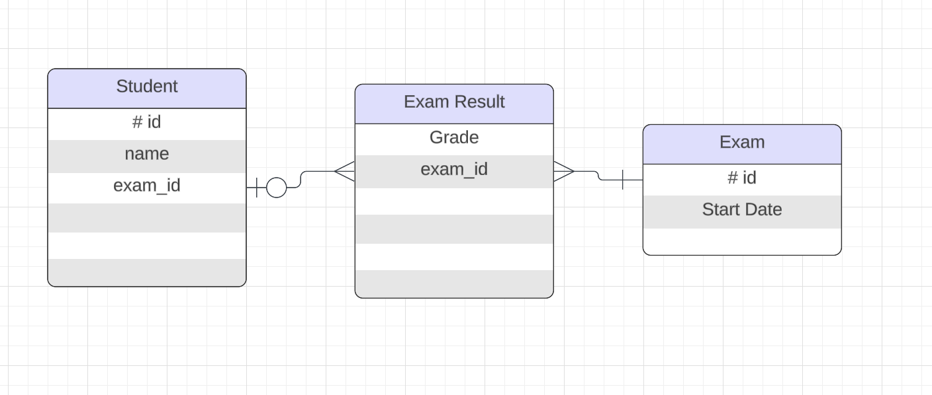

1. ​

## Faculty (Supertype)

* + ID
  + First Name
  + Last Name
  + Email
  + Login Date
  + Login Time
  + Details

## FullTimeFaculty (Subtype)

* + Salary
  + Insurance Plan

## PartTimeFaculty (Subtype)

* + Hourly Rate

1. ​

Exclusive Relationship can be modeled by having **Course** as the main entity and **Seated** and

**Online** as the subtype entities. Each course can only be in either of the locations.

## Course (supertype)

* + Course ID
  + Course Name

## Seated (subtype)

* + Building Name
  + Room Number
  + Date/Time Offered

## Online (subtype)

* + Logon ID
  + Password

1. ​
   * A hotel will have many floors
   * Each floor can have many suites
   * Each suite can have many rooms
   * The unique identifiers can be: Hotel ID, Floor ID, Suite ID, and Room ID

## Hotel

* **Attributes:**
  + Hotel ID (Unique Identifier)
  + Hotel Name
  + Address
  + Phone Number
  + Email

## Floor

* **Attributes:**
  + Floor ID (Unique Identifier)
  + Floor Number
  + Hotel ID (Foreign Key, references Hotel)

## Suite

* **Attributes:**
  + Suite ID (Unique Identifier)
  + Suite Number
  + Floor ID (Foreign Key, references Floor)

## Room

* **Attributes:**
  + Room ID (Unique Identifier)
  + Room Number
  + Suite ID (Foreign Key, references Suite)
  + Room Type (e.g., Single, Double, Suite)

1.

Hierarchical structure

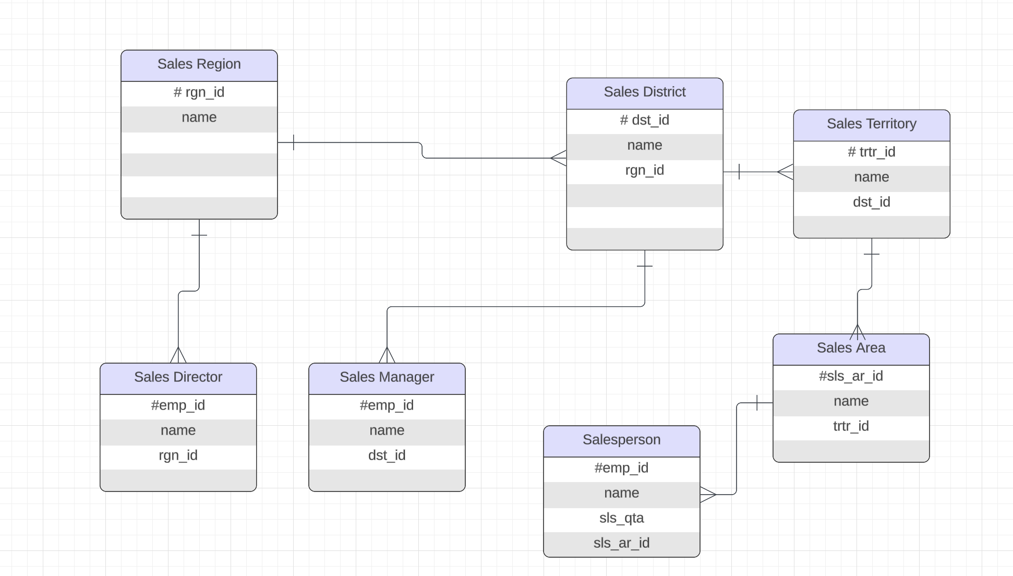

Recursive structure

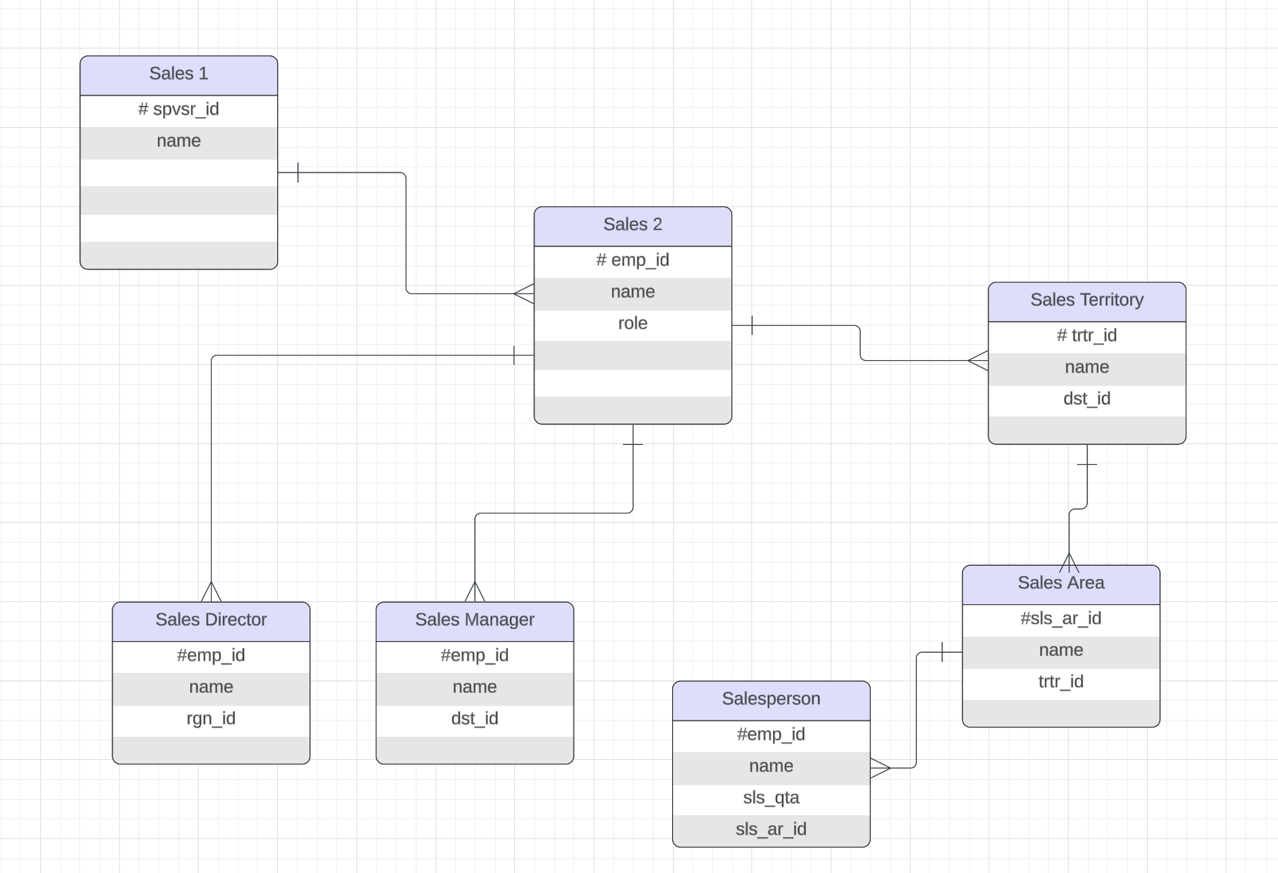

1.

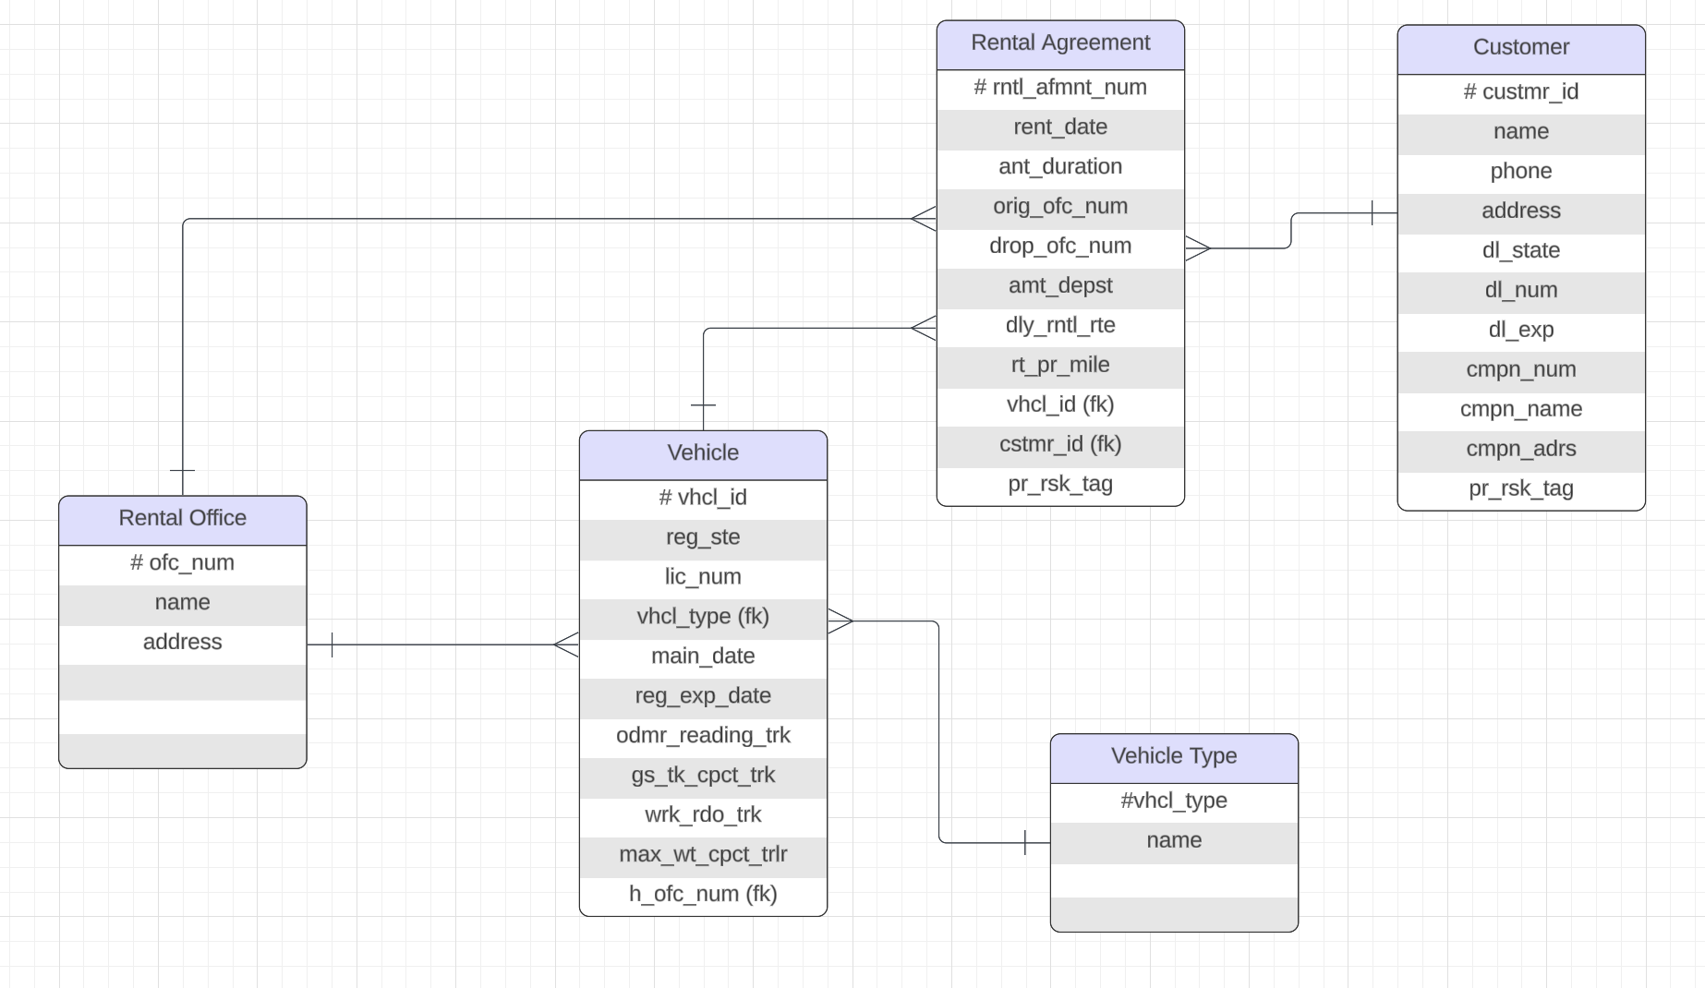

3-2: Tracking Data Changes

**a.**

1. Adding a new attribute called **attempt_num** under Student Course Detail would help determine the number of attempts a student has taken and the grade received.

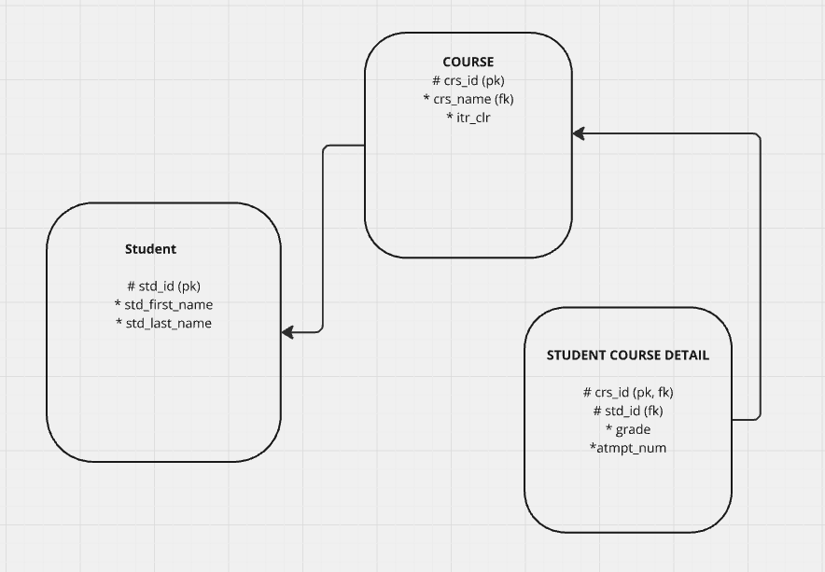

2.

1. Start Time is part of UID of ASSIGNMENT because multiple exams could fall under the same date.
2. ​
   1. You need to ensure that start time does not overlap with another exam for the

same class. This represent conditional non-transferability because it makes sure a class is not double booked

* 1. The exam date should be within the academic term. This represent conditional non-transferability because exams should occur within a valid period
  2. End time must be later than start time. This represents conditional non-transferability because it is logically consistent.

3-3: Normalization and Business Rules

**a.**

1.

|  |  |  |
| --- | --- | --- |
| **Item ID** | **Color** | **Unit Price** |
| IT001 | Red | $16.56 |
| IT001 | Blue | $16.56 |
| IT002 | Yellow | $17.48 |
| IT003 | Green | $18.76 |
| IT004 | Blue | $20.00 |
| IT004 | Yellow | $20.00 |

2.

Supplier Table

|  |  |
| --- | --- |
| **Supplier ID** | **Store ID** |
| SP001 | S1 |
| SP001 | S3 |
| SP002 | S1 |
| SP003 | S2 |
| SP004 | S3 |

Store Table

|  |  |
| --- | --- |
| **Store ID** | **Location** |
| S1 | New York |
| S3 | Vermont |
| S1 | New Hampshire |
| S2 | Rhode Island |
| S3 | Illinois |

3.

Book Table

|  |  |  |
| --- | --- | --- |
| **Book ID** | **Category ID** | **Price** |
| 1 | 1 | $27.99 |
| 2 | 2 | $17.99 |
| 3 | 1 | $20.99 |
| 4 | 3 | $40.99 |
| 5 | 2 | $19.99 |
|  |  |  |

Category Table

|  |  |
| --- | --- |
| **Category ID** | **Category Description** |
| 1 | Cooking |
| 2 | Travel |
| 1 | Cooking |
| 3 | Computers |
| 2 | Travel |

**b.**

1. ​
   * COURSE should belong to ACADEMIC SESSION
   * There should be another table that has the number of working days, number of days off and the eligibility for exam
   * Parent 2 First Name and Last Name should not be optional attributes
   * Login Date/Time details should be a different table
   * Exam Type should be a different table
   * **c.**
2. ​

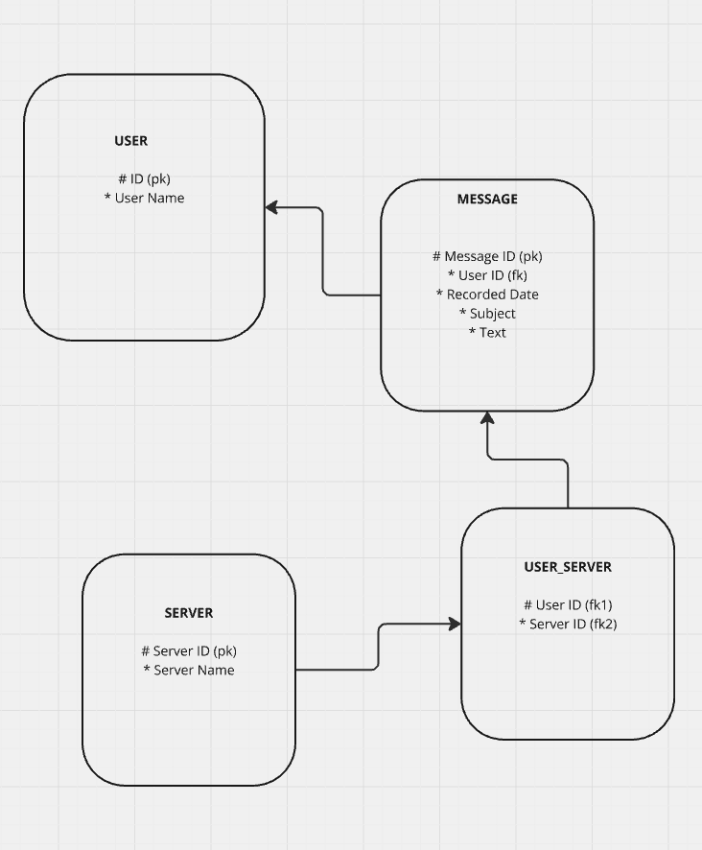

1. A separate color scheme table is needed because it would make sense for paint color and interior color to be dependent on color scheme.

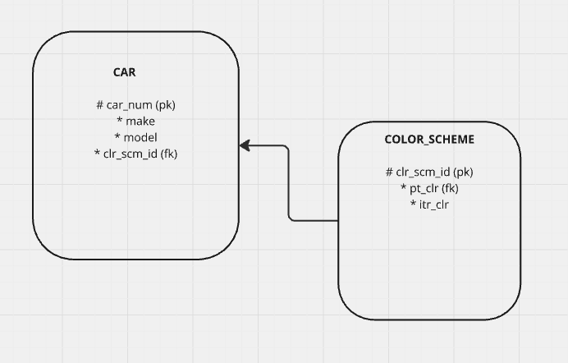

**d.**

1. The following business rules can be implemented:
   * A book should have a unique title, isbn, year, and price
   * A book should be associate with one or more authors
   * An author should have unique name and contact information
   * A publisher should also have unique name and contact information
   * Warehouses should have unique IDs and can have different books
   * A book can be in multiple warehouses
   * Customers should have unique contact details
   * Customers can have multiple shopping carts which can contain multiple books. Quantity should be recorded
   * Billing and shipping information should be required to complete purchase
   * Email notifications should be sent after purchase
2. ​

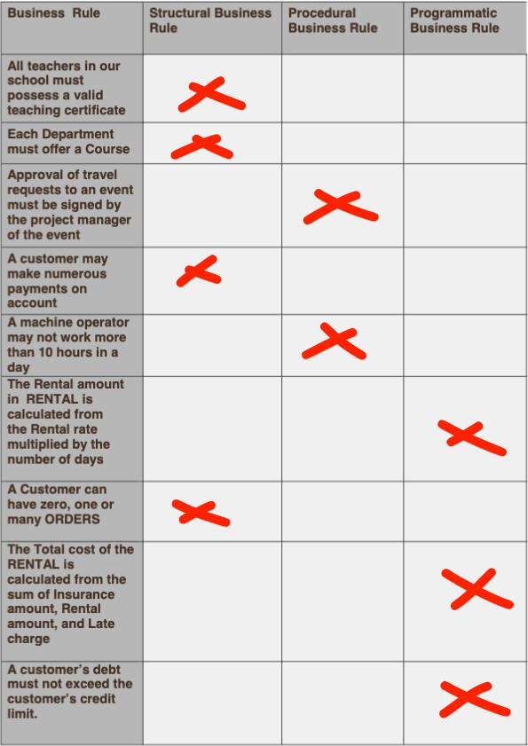

3-4: Data Modeling Terminology and Mapping

**a.**

1. Match the ERD elements to their corresponding data elements.

|  |  |
| --- | --- |
| **Analysis** | **Design** |
| Attribute | Column |
| Entity | Table |
| ER Model | Physical design |
| Instance | Row |
| Primary UID | Primary Key |
| Relationship | Foreign Key |
| Secondary UID | Unique Key |

1. ​
   1. Primary Key
   2. Foreign Key
   3. Unique Key
   4. Primary Key
   5. Optional attribute
2. ​
   1. ATS
   2. PLS
   3. CTMS
3. ​

|  |  |  |  |
| --- | --- | --- | --- |
| SONG | EVENT | CUSTOMER |  |
| X | X |  | Title |
| X | X |  | Description |
| X | X |  | Venue |
|  |  | X | First Name |
| X | X | X | Phone Number |
| X | X |  | Release Date |
|  |  | X | Last Name |
| X | X |  | Type |
|  | X | X | Email Address |

**b.**

PARENT INFORMATION

|  |  |  |
| --- | --- | --- |
| **Key Type** | **Optionality** | **Parent Information** |
| pk |  | id |
|  | * | p1_first_name |
|  | * | p1_last_name |
|  | * | p2_first_name |
|  | * | p2_last_name |

EXAM TYPE

|  |  |  |
| --- | --- | --- |
| **Key Type** | **Optionality** | **Exam Type** |
| pk | * | id |
|  | * | exam_name |
|  | * | exam_dsc |

STUDENT

|  |  |  |
| --- | --- | --- |
| **Key Type** | **Optionality** | **Student** |
| pk | * | id |
|  | * | first_name |
|  | * | last_name |
|  | * | rgtn_yr |
|  | * | email |
| fk1 | * | prt_id |
|  | o | p1_first_name |
|  | o | p1_last_name |

DEPARTMENT

|  |  |  |
| --- | --- | --- |
| **Key Type** | **Optionality** | **Department** |
| pk |  | id |
|  | * | name |
|  | * | head |
| fk1 | * | crs_id |
|  | * | crs_name |

FACULTY

|  |  |  |
| --- | --- | --- |
| **Key Type** | **Optionality** | **Parent Information** |
| pk |  | id |
|  | * | first_name |
|  | * | last_name |
|  | * | email |
|  | * | salary |
|  | o | ins_pln |
|  | * | hrly_rt |
| fk1 | * | dpt_id |
|  | * | dpt_name |
|  | o | dpt_head |

COURSE

|  |  |  |  |
| --- | --- | --- | --- |
| **Key Type** | **Optionalit y** |  | **Course** |
| pk | **\*** |  | id |
|  | **\*** |  | name |
| fk1 | **\*** |  | dept_id |
|  | **\*** |  | dept_name |
| fk2 | **\*** |  | acdmc_ssn_id |

ACADEMIC SESSION

|  |  |  |
| --- | --- | --- |
| **Key Type** | **Optionality** | **Academic Session** |
| pk | **\*** | id |
|  | **\*** | name |